Scoil Mháirtín
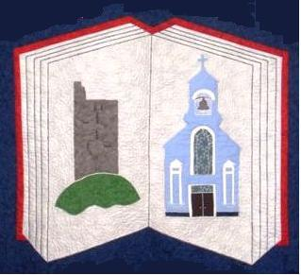
Kilworth, Co. Cork
Tel: 025-68990
Email: office@kilworthns.ie

ANNUAL ADMISSION NOTICE
in respect of admissions for the 2024/2025 school year Admission Policy and Application Form
A copy of the school’s Admission Policy and the Application Form for Admission for the 2024-2025 school year is available as follows: –
To download at: www.kilworthns.ie
On request: By emailing office@kilworthns.ie
or writing to: Scoil Mhairtin National School, Kilworth, Co. Cork (P61 D504)

PART 1 Application and Decision Dates for admission:

Junior Infants 2024/2025.
The school will commence accepting applications for admission on | 25/10/2023
The school shall cease accepting applications for admission on | 15/11/2023
The date by which applicants will be notified of the decision on their application is | 22/11/2023
The period within which applicants must confirm acceptance of an offer of admission is | 13/12/2023
*Failure to accept an offer within the prescribed period above may result in the offer being withdrawn

Special Class 2024/2025.
The school will commence accepting applications for admission on | 25/10/2023
The school shall cease accepting applications for admission on | 15/11/2023
The date by which applicants will be notified of the decision on their application is | 22/11/2023
The period within which applicants must confirm acceptance of an offer of admission is | 13/12/2023
*Failure to accept an offer within the prescribed period above may result in the offer being withdrawn

Note: The school will consider and issue decisions on late applications in accordance with the school’s Admission Policy.

Number of places being made available in the 2024/2025 school year.

The number of places being made available in Junior Infants is: | 35
The number of places being made available in all other classes is: | 5
The number of places being made available in the Special Class is: | 0

