Scoil Mháirtín, Cill Uird
Tel: 025-68990

Junior Infants - Booklist 2023/2024

Other Items:
1 clear zipped pencil case (for their new words)
1 x B5 mesh storage wallet
3 x pencils, 1 x topper, 1 x rubber
3 x Large Pritt sticks (labelled)
1 x A4 size Whiteboard (available in Discount Shops)
3 x Whiteboard Markers (labelled)
3 x A4 zipped mesh folders
Set of Twistables (set of 12)
1 x A5 Clip Folder
Gumshield (in labelled container)
Face Cloth (labelled)
Clear Lunch Box (for stationery) e.g.

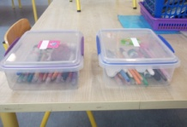

SCHOOL SUBSCRIPTION PAYABLE: €50
This includes: Pupil Personal Insurance – 24 hour cover; Photocopying; Arts & Crafts; Dance Teacher; Athletics Coaching; STEM Workshops, etc.

