Scoil Mháirtín
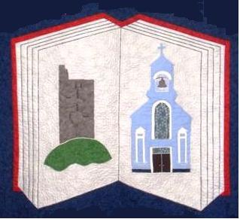
Kilworth, Co. Cork
Tel: 025-27446
Email: kilworthnationalschool@gmail.com

ANNUAL ADMISSION NOTICE
in respect of admissions for the 2021/2022 school year Admission Policy and Application Form
A copy of the school’s Admission Policy and the Application Form for Admission for the 2021-2022 school year is available as follows: –
To download at: www.kilworthns.ie
On request: By emailing kilworthnationalschool@gmail.com , or writing to: Scoil Mhairtin National School, Kilworth, Co. Cork (P61 D504)

PART 1 Application and Decision Dates for admission:

Junior Infants 2021/2022.
The school will commence accepting applications for admission on | 18th January 2021
The school shall cease accepting applications for admission on | Please Contact  The School  025 27446  kilworthnationalschool@gmail.com
The date by which applicants will be notified of the decision on their application is
The period within which applicants must confirm acceptance of an offer
of admission is
*Failure to accept an offer within the prescribed period above may result in the offer being withdrawn

Note: The school will consider and issue decisions on late applications in accordance with the school’s Admission Policy.

Number of places being made available in the 2021/2022 school year.

Number of places available: | 45
Number of applications received:
Number of offers made and accepted:

